Creating Microservices for account and loan

For Account

package com.cognizant.account.controller;

import java.util.HashMap;
import java.util.Map;

import org.springframework.web.bind.annotation.GetMapping;
import org.springframework.web.bind.annotation.PathVariable;
import org.springframework.web.bind.annotation.RequestMapping;
import org.springframework.web.bind.annotation.RestController;

@RestController
@RequestMapping("/accounts")
public class AccountController {

@GetMapping("/{number}")
public Map<String, Object> getAccountDetails(@PathVariable String number) {
Map<String, Object> response = new HashMap<>();
response.put("number", number);
response.put("type", "savings");
response.put("balance", 234343);
return response;
}
}

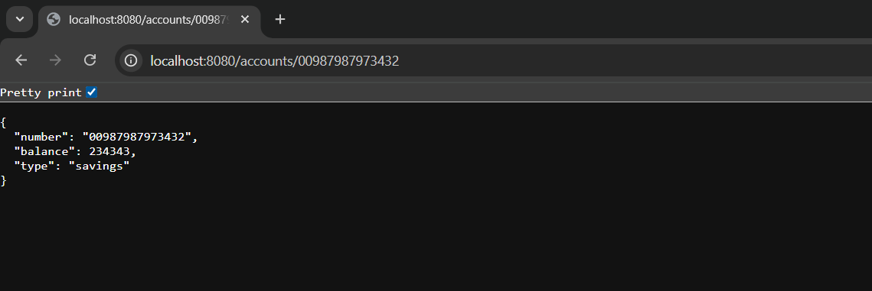

For Loan

package com.cognizant.loan.controller;

import java.util.HashMap;
import java.util.Map;

import org.springframework.web.bind.annotation.GetMapping;
import org.springframework.web.bind.annotation.PathVariable;
import org.springframework.web.bind.annotation.RequestMapping;
import org.springframework.web.bind.annotation.RestController;

@RestController
@RequestMapping("/loans")
public class LoanController {

@GetMapping("/{number}")
public Map<String, Object> getLoanDetails(@PathVariable String number) {
Map<String, Object> response = new HashMap<>();
response.put("number", number);
response.put("type", "car");
response.put("loan", 400000);
response.put("emi", 3258);
response.put("tenure", 18);
return response;
}
}

